**Analysis of Overnight Risk for the S&P 500**

**2012-2017**

Author: Louis Michael Lombardo, T3 Trading, LLC.

**OVERVIEW**: Overnight risk affects all market participants. However, it’s of particular concern to new traders. This study provides insight into which stocks in the S&P 500 have had the highest and lowest overnight gap movement in both actual $US dollar and percentage terms from 1/1/2012 to 3/13/2017.

**METHODOLOGY**: Market data for the analysis was mined from the Yahoo! Finance pages through the Pandas DataReader package using Python3.6. However, tickers for each individual stock in the S&P 500 were collected from a csv file found on a Github repository. Specifically, daily OHLC (open, high, low, close) data from 1/1/2012 to 3/10/2017 was extracted and stored into a SQLite3 database. The absolute value of each daily gap for every stock during that time period is calculated using the previous day’s closing print vs. the following day’s opening print and stored in the same database. Gap Percentage is calculated through the following formula: GAP_PRCT = ABS((gap/previous day’s closing print) * 100).

**RESULTS**: Not surprisingly, the largest dollar gaps occurred in high-beta names with Priceline leading the way averaging a daily gap of over +/-$6. Alphabet (GOOGL & GOOG), Intuitive Surgical, Chipotle, Amazon, Apple, Netflix, Autozone, Regeneron and Biogen rounded out the top 10 with average gaps ranging from +/-$4 to +/-$2, respectively (Figure 1). Frontier Communications had the smallest average dollar gap in the S&P 500, averaging approximately +/-$.04. Xerox and smaller financials, including Huntington Bancshares, KeyCorp, and Regions Financial are also in the bottom ten with average gaps of less than +/- $.10. (Figure 2)

When analyzing daily gaps on a percentage basis, the data reveals some interesting information. From 2012-2017, Chesapeake Energy and Freeport-McMoRan were the two stocks with the highest average daily gaps of close to +/- 1.2%. Other energy and commodity names in the top 10 include Transocean and Newmont Mining. Netflix remains the sole company that’s in the top 10 highest gaps on both a percentage and dollar basis (Figure 3). Utility companies comprised of the lowest gap percentage openings with Southern Company leading the way with an average daily gap opening of +/- .25% followed by Consolidated Edison, DTE Energy and SCANA, respectively.

**CONCLUSION:** Overnight risk remains a normal part of financial market price action. New traders with limited capital need to recognize the risk associated with carrying overnight positions of high beta equities on both a dollar and percentage basis. Avoiding the top 10-20 stocks listed in figure 1 results in a lower beta for a portfolio, but can significantly reduce large overnight losses. Conversely, new traders also need to avoid creating a portfolio of low-beta equities listed in the top 10 of figures 2 and 3. A portfolio filled with too many of these stocks results in significantly lower overnight risk, but also guarantees much smaller returns.

Figure 1:

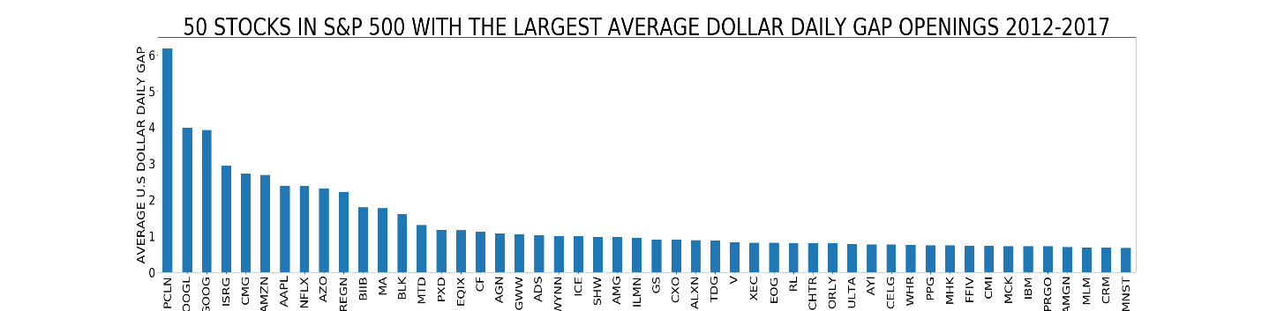

Figure 2:

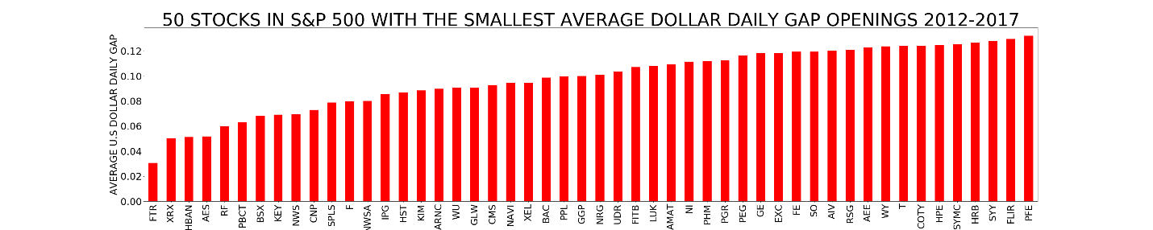

Figure 3:

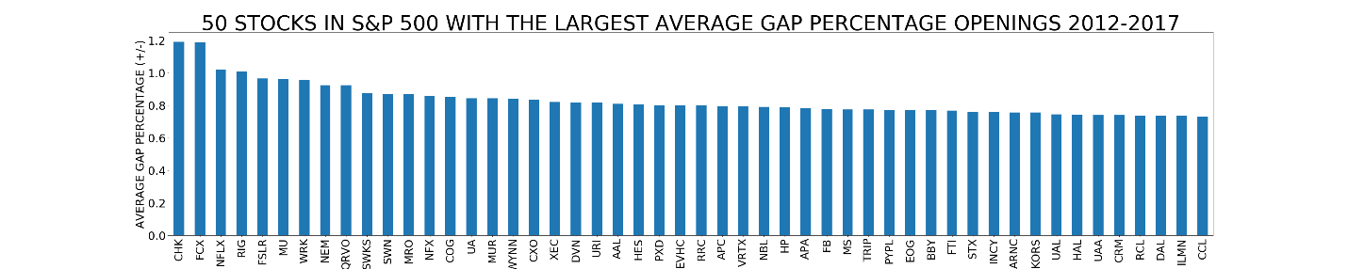

Figure 4:

